Assignment no 10

1) Write a query that produces all pairs of Salespeople who are living in the same city. Exclude combinations of Salespeople with themselves as well as duplicate rows with the order reversed.

Ans :-

select a.sname, b.sname, a.city from SALESPEOPLE a, SALESPEOPLE b where a.city = b.city and a.sname<b.sname;

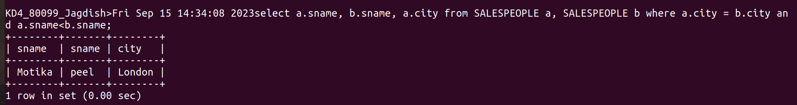
2) Write a query that produces the names and cities of all customers with the same rating as Hoffman.

Ans :-

select a.cname, a.city from CUSTOMERS a,CUSTOMERS b where a.rating=b.rating and b.cname="Hoffman";

